LESSON NOTES FOR LANGUAGE MIDDLE CLASS TERM ONE

Week 1

P.d 1

* Working in groups.
* Helping one another.
* Telling people by their names.
* Identifying people by their names.

P.d 2

Letters

Copy and write

a b c d e f

__ ___ ____ ___ ___

Reading

Writing

Speaking

Listening

P.d 3

Copy and write

Cat sun man

P.d 4

Rhyme

Actions

Looking at

Pointing to

Pd 5

Riddle

Colouring blue

Green

Red

Activities

Reading

Week 2

Pd 1

Read and match.

a f

b e

c d

d c

e b

f a

activities

* Reading
* Writing
* Speaking
* Listening

P.d 2

Reading and fill in the missing letters.

a b

a b __

a b c ___

a b c d ___

P.d 3

Matching pictures to words

Hat

Car

Tin

Box

P.d 4

Situational game

Making request through games following

Command, including prepositions put the ball on the chair.

P.d 5

Copy and write letters

g h i j k l

Week 3

Period 1

Content

Match and name the pictures







Activities

Reading

Matching

Drawing

Period 2

Content

Matching the same letters and write

g k

h j

j g

j g

k i

Activities

Reading

Matching

Writing

Period 3

Matching words to pictures

Axe

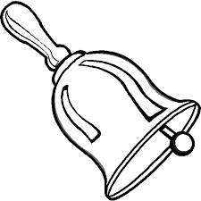

Bed

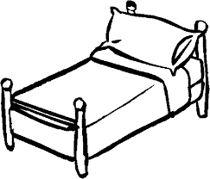Cup

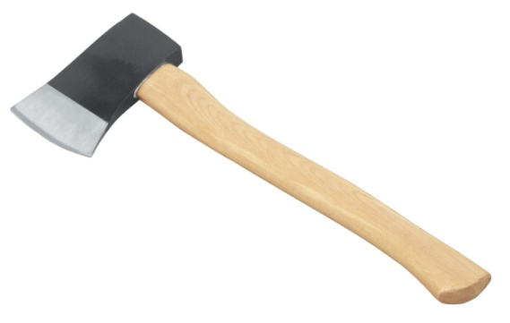Bell

Period 4

Content

Situational game

Fill in the missing letters.

g _____ i _______

k _____ h ______

j _____

Write the letters correctly.

Activities

Reading

Writing

Period 5

Content

Circle the same words.

axe cup axe

bed bed hut

sun cat sun

Ring the correct word for the picture.

 axe cup

 hut bed



sun cat

Activities

Reading.

Recognising word and circling

Week 4

Content

Rhyme

Recognition of colour

Blue, red, yellow

Activitie

* Reading
* Reciting
* Identifying the given colour

Pd 2

Copy and write letters

M – r

K,l,m,n,o,p,q,r

Activities

* Reading recognising letters
* Copying

Pd 3

Content

Vocabulary

New word, egg, dog, hut, ear,

Circle the same

Egg, bag, egg

Activities

* Reading
* Recognising words

Pd 4

content

* Poem
* Actions
* Sitting
* Running
* Pointing

Activities

Reading

Acting

Question and answer.

Pd 5

Content

Circle the same letters.

|  |  |  |
| --- | --- | --- |
| M | m | a |
| n | b | n |
| p | p | e |
| Q | P | q |

Week 5

Pd 1

Read and

cow ________ fish _____

book ______

tree ______

New word

Vocabulary

Cow, book, tree, fish

Activities

* Recognising
* Reading
* Writing

Pd 2

Copy and write

S t u v

___ ___ ____ ___

Tick the different letter

|  |
| --- |
| s s p |
| t o t |
| n u u |
| v y y |

Activities

* Reading
* Recognising letters
* Copying

Pd 3

Content

Circle the correct word for the picture.

cow book

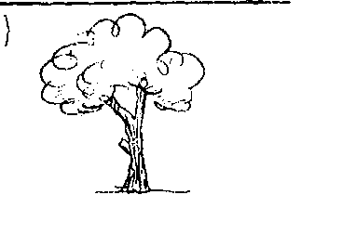 tree sun

fish box

Activities

Content

Match capital to small letters and write.

S v ____

T u _____

U t ____

V s ___

Circle the odd man

y t t

u w w

z z r

y y x

Activities

* Reading
* Recognising
* Matching and writing

Pd 5

Content

Vocabulary

New words

Man, pin, apple, eye

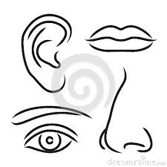Name the pictures.

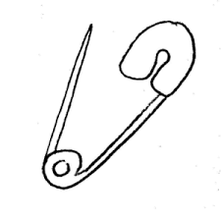

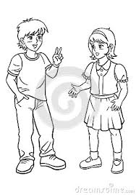 ­­_____ ______

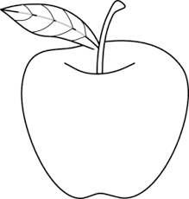

______ _____

Week 6

Pd 1

Contents

Fill in the missing letter.

a b ___ d __

f ___ h I v ___

Activities

* Letter recognition
* Reading
* Finding in the missing letter.

Pd 2

Content

* Following command including prepositions like
* Put the pen in the tin.

Activities.

Content

* Situations game
* Actions
* Skipping
* Jumping
* Dancing
* Sweeping

Activities

* Listening
* Speaking
* Reading
* Writing
* Drawing

Period 4

Content

Circle the same letters

w a w

z k z

y y c

Write the letters correctly.

Activities

* Reading
* Recognising letters
* Writing
* Circling

Pd 2

Content

Vocabulary

New words

Leg, nose, flower, bird

Activities

* Reading
* Recognising words.

Week 7

Pd 1

Content

Following command including

Prepositions

Put the box near the pot.

Activities

* Reading
* Recognising pictures

Pd 2

Copy the capital letters.

|  |  |  |  |  |
| --- | --- | --- | --- | --- |
| A | b | c | d | e |
| A | B | C | D | E |

Activities

Reading

Recognising

Period 3

Content

Vocabulary

Drum, flower, shoe, leaf, bottle

Circle the same words

drum flower drum

shoe tin shoe

bottle bottle cup

Pd 4

Content

Match the same and write.

Bottle flower ________

Leaf drum_______

Drum leaf ______

Flower bottle _____

Activities

* Reading
* Matching

Pd 5

Content

Following command including (action)

Who is ______?

_____ is _____

Small letter (use learnt letters)

Write correctly.

Activities

* Reading
* Recognising
* Writing

Week 8

Pd 1

Content

Actions

* Digging
* Carrying

Activities

* Reading
* Recognising pictures
* Writing

Pd 2

Trick words

He, she,

We, where

He is a boy

I can see a ball

We are singing

Where is the ball?

Activities

* Recognising
* Reading
* Responding

Period 3

Make sentences using it is a --------------

 It is a book.

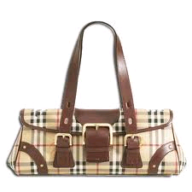 It is a tin.

It is a bag.

It is a box.

Activities.

* Writing
* Reading

Pd 4

Content

Make sentences for the pictures it is ----------?

 ______________________

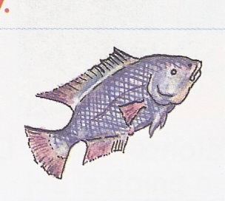

___________________

___________________

____________________

Activities

Name the pictures

Broom

Chair

Kite

Egg

Table

Car

Fill in the missing letters.

 Br ___m

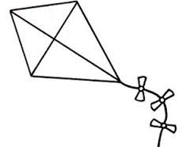K ___ te

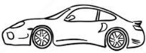 C ___ r

 E____

Write letters a-1

Read and draw.

In_______ near________

On_______ under_______

Write capital letters.

a= d= g=

b= e= h=

c= f= i=

Ring the capital letters.

a b f D

e c E

Match small to capital letters.

I L

j M

k N

l O

m I

n J

o K